Sprint 2 Report

* Team Name: Team RetailGo
* Product Name: RetailGo
* Date: 11/ 11/23

**Actions to Stop Doing:**

* The team needs to stop putting out stopgap solutions when they aren’t absolutely necessary. They ended up having to be redone in the future, directly increasing our architectural debt
* Each individual in the team needs to be a bit more honest about the work they are actually able to do.
* Understand the urgency of Prerequisite Tasks and make sure they are completed ahead of time.

**Actions to Start Doing:**

* The team will need to start adhering to the agreed upon Coding standards for Go + Typescript/React for Sprint 3.
* The team will need to work on creating and supporting a Continuous Integration Workflow using Github Actions by being on top of test development.

**Actions to Keep Doing:**

* The team needs to keep on using pull requests when merging code to the main branch. It avoids code breakage on our production branch and has been very helpful in rolling back commits when necessary.
* Team members that work on different but related components need to continue keeping strong communication between each other to keep everyone involved in the overall larger component on the same page.

**Work Completed:**

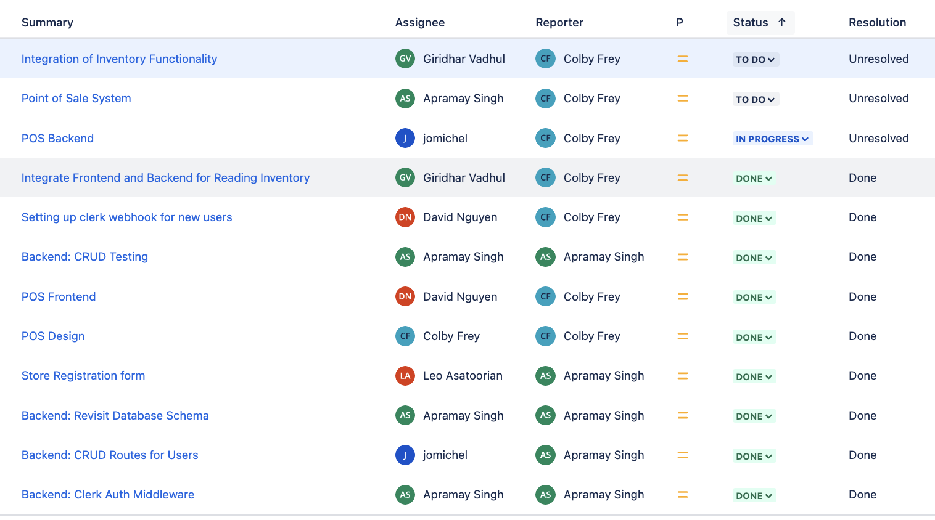

**User Stories for the Sprint:**

* {1}As an owner, I want to ensure that only authorized personnel have access to my store to avoid theft or other objectionable transactions.
* {4}As an owner, I want to get real time stock updates after transactions so that they can track stock levels
* {1}As an employee, I want to be able to process customer transactions, so that I can efficiently handle customer purchases.

The user stories that were **completed are in green**, and the ones that aren’t **completed are in red**.

**Work Completion Rate:**

* **User Stories Completed in Sprint: -> 1**
* **Total number of estimated ideal work hours completed during prior sprint -> 49**
* **Total number of days during the prior sprint -> 14**
* **User Stories/day -> 0.07**
* **Ideal work hours/day -> 4.6 hrs**
* **Average User Stories/day -> 0.11**
* **Average Ideal work hours/day -> 3.9 hrs**

**Burn Up Chart:**

